# Granting and Revoking Access in SQL

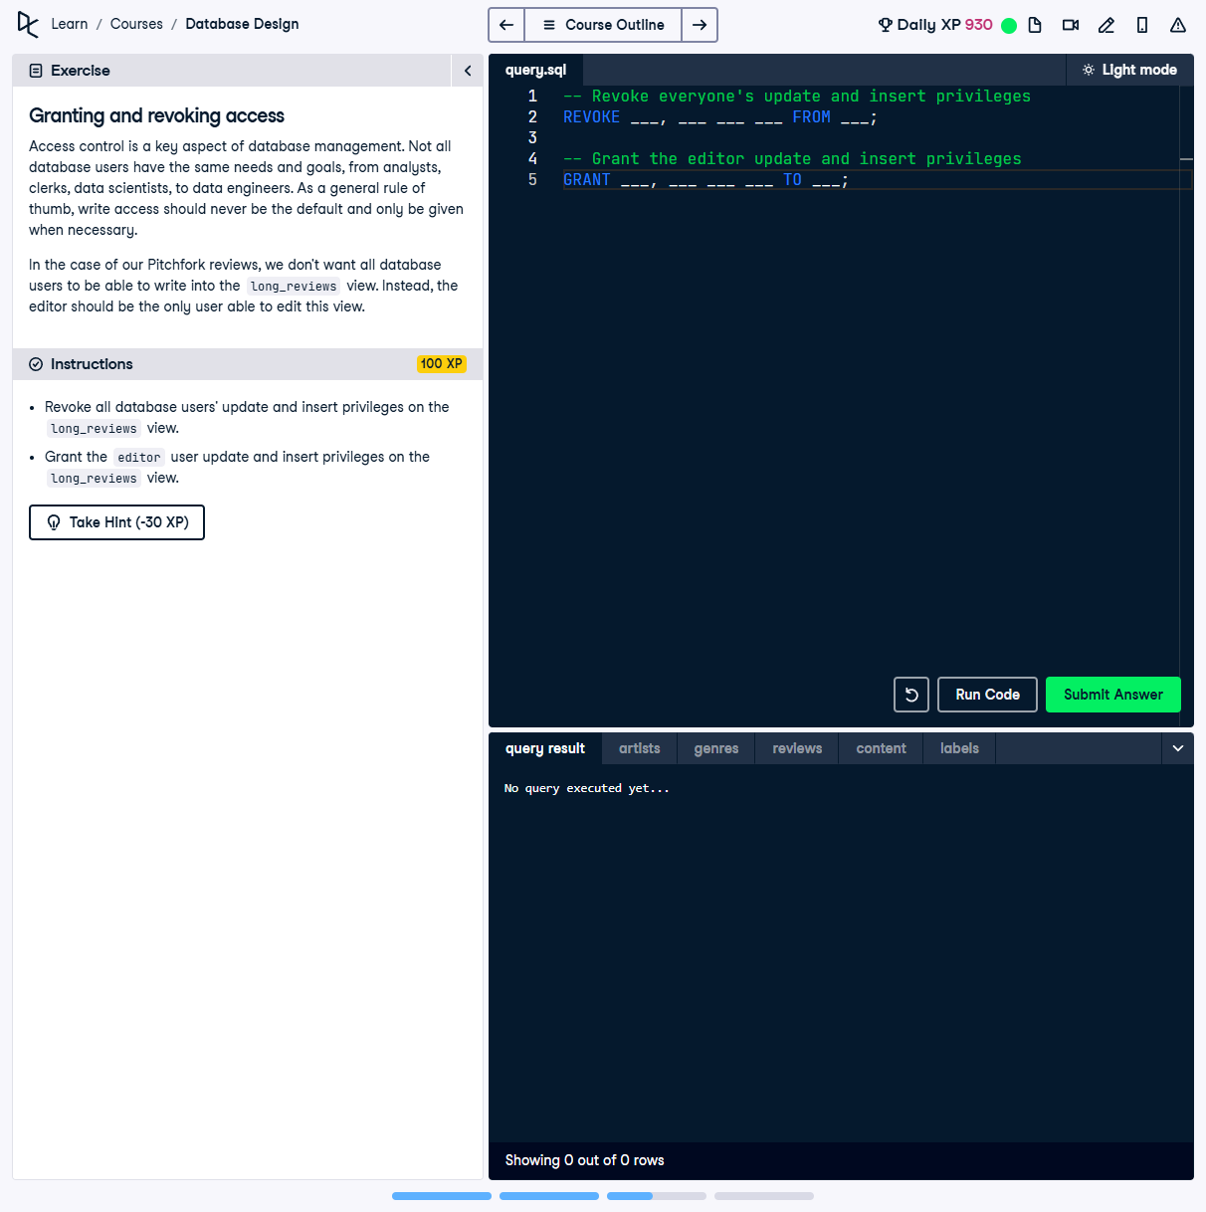

## Question:

Access control is a key aspect of database management. Not all database users should have the same privileges. We need to revoke all users' update and insert privileges on `long_reviews`, and then grant these privileges only to the `editor` user.

## Instructions:

1. Revoke all database users' update and insert privileges on the `long_reviews` view.

2. Grant the `editor` user update and insert privileges on the `long_reviews` view.

## Full Answer (SQL Code):

-- Revoke everyone's update and insert privileges  
REVOKE UPDATE, INSERT ON long_reviews FROM PUBLIC;  
  
-- Grant the editor update and insert privileges  
GRANT UPDATE, INSERT ON long_reviews TO editor;

## Explanation of the Answer:

The `REVOKE` statement removes `UPDATE` and `INSERT` permissions from all users (`PUBLIC`) on `long_reviews`. Then, the `GRANT` statement explicitly grants these privileges to the `editor` user, ensuring only they can modify this view.